David Thomsen

CSI-300

Reading Links:

* [Murach's](https://drive.google.com/file/d/1BAos-Ykx-2Oc50aTA0QIvaXNQZwyCdTD/view?usp=sharing)
* [Churcher](https://learning-oreilly-com.cobalt.champlain.edu/library/view/beginning-database-design/9781430242093/9781430242093_Title.xhtml)

Assignment:

* Churcher: Exercise 1-1 (p 8)
* Churcher: Exercise 2-1 (p 24)

Sources:

* [Class Diagram UML Example](https://www.visual-paradigm.com/guide/uml-unified-modeling-language/what-is-class-diagram/)

**Exercise 1-1**

A school is planning some outdoor activities for its students. The staff wants to create a database of how parents can help. The secretary sets up the database table in Figure 1-7 to keep the information.

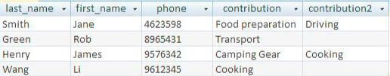

**What problems can you foresee in making good use of this information?**

One main issue I see is that there is two contributions columns and the data is not standardized within the columns in a way that makes sorting efficient. I believe that creating a separate table so that

**Suggest some better ways that this information could be stored.**

I believe this should be set into two different tables with one table storing the parents information such as ID, NAME, and PHONE, with a separate contributions table that stores the contributions as well as the assigned parent. There would maybe need to be another table that sorts the parents into groups based on the contributions that they are bringing.

| Parent_id | first_name | last_name | Phone |
| --- | --- | --- | --- |
| 1 | Jane | Smith | 4623598 |
| 2 | Rob | Green | 9124746 |

| Contribution ID | Contribution name | cont_group |
| --- | --- | --- |
| 1 | Food Prep | 1 |
| 2 | Cooking | 2 |

**Exercise 2-1**

A small sports club keeps information about its members and the fees they pay. The secretary wants to be able to record when members pay and print a report similar to that in Figure 2-20.

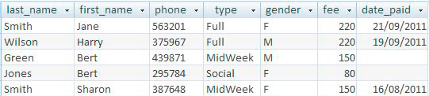

**a) Think about when the different pieces of data might be entered. Sketch an initial use case diagram for data entry.**

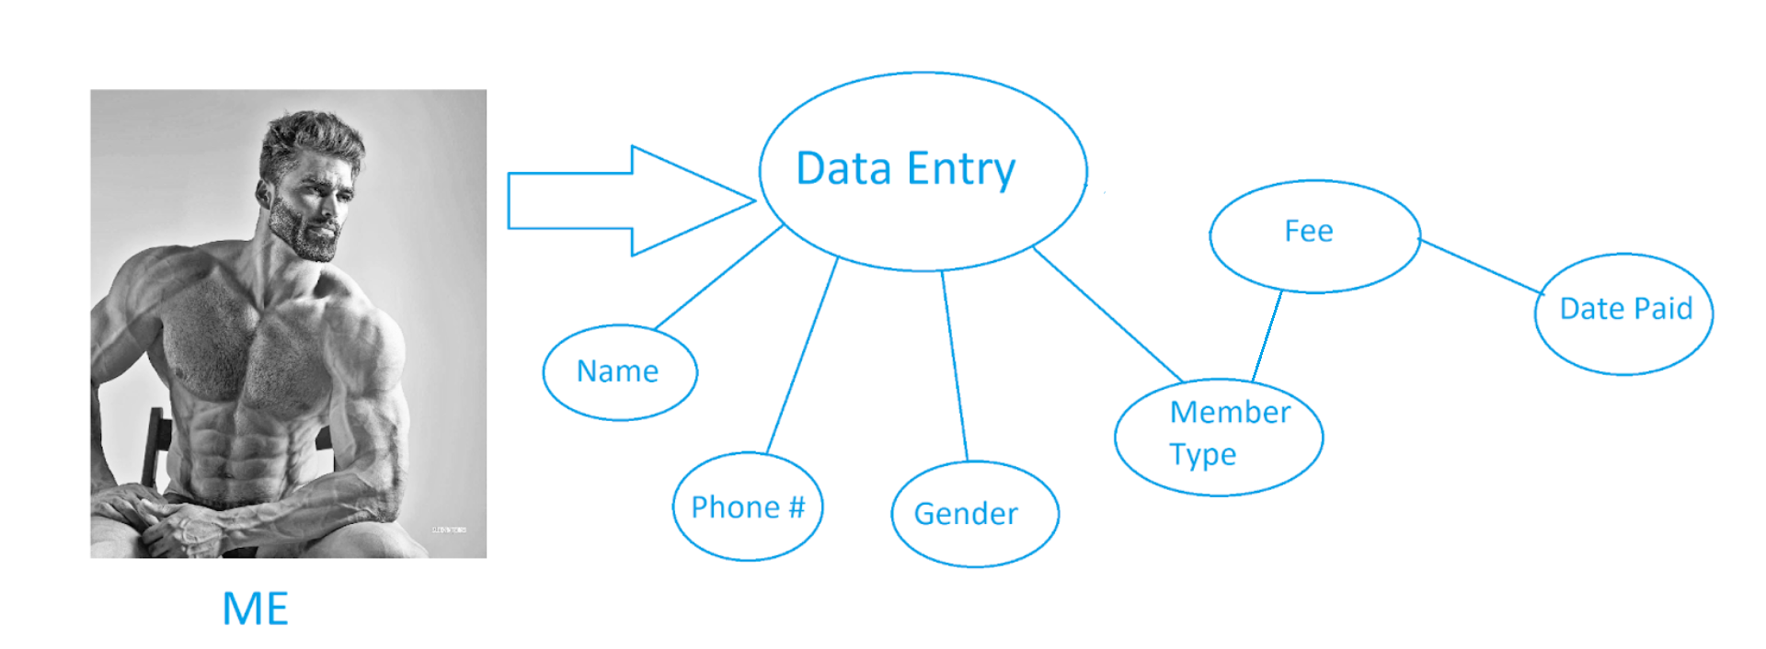

**b) Consider what different things you are keeping information about and sketch a simple class diagram.**

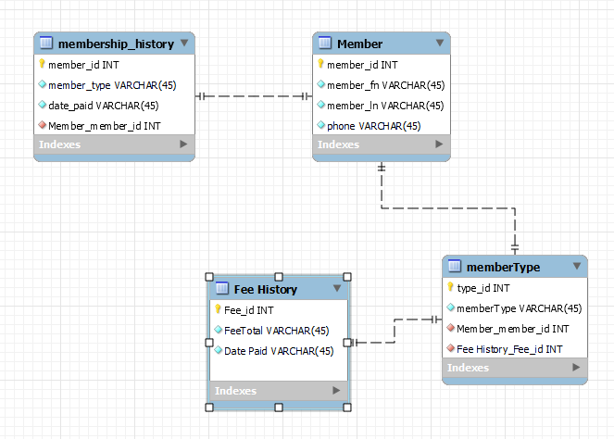

**c) What options could you suggest to the club for different ways a report could be presented? Does your class diagram have the information readily available?**

My diagram breaks it down into a few groups that change the way the data was originally collected all in one table. This collects data about the members, stores their history, and assigns fees to members based on the type of membership. This includes much more information and in a much more efficient way than the previous table.